Lancashire and South Cumbria Women’s Health Board
Description | Comment
Title | Lancashire and South Cumbria (L&SC) Integrated Care Board  Women’s Health board Terms of Reference
Author | Sarah Bibby
Date Created | 22/4/2024
Version | V1.0
Approved By | Woman’s Health Board
Review Date
Responsible Owner | Vanessa Wilson
Publish on Public Website

Amendment History:
Version | Date | Comment on Changes

Document Status: This is a controlled document. Whilst this document may be printed the electronic version posted on the intranet is the controlled copy. Any printed copies of the document are not controlled.

- Background
The Women’s Health Strategy for England (2022) is a 10-year plan for boosting the health and wellbeing of women and girls, and for improving how the health and care system listens to women. The strategy encourages the expansion of women’s health hubs across the country to improve access to services and health outcomes, these could be.
Women’s health hubs bring together healthcare professionals and existing services to provide integrated women’s health services in the community, centred on meeting women’s needs across the life course. Hub models aim to improve access to and experiences of care, improve health outcomes for women, and reduce health inequalities.
Women’s health hubs (‘hubs’) are understood as a model of care working across a population footprint and are not necessarily a single physical place.
The Women’s Hubs have a duty to provide core services by December 2024. These include, but not limited to: Menstrual problems assessment and treatment, menopause assessment and treatment, long-acting reversible contraception (LARC) for both contraceptive and gynaecological reasons, preconception care, breast pain assessment and care, pessary fitting and removal, cervical screening and screening and treatment for sexually transmitted infections including HIV testing. The strategy aims to support women during throughout the life course:

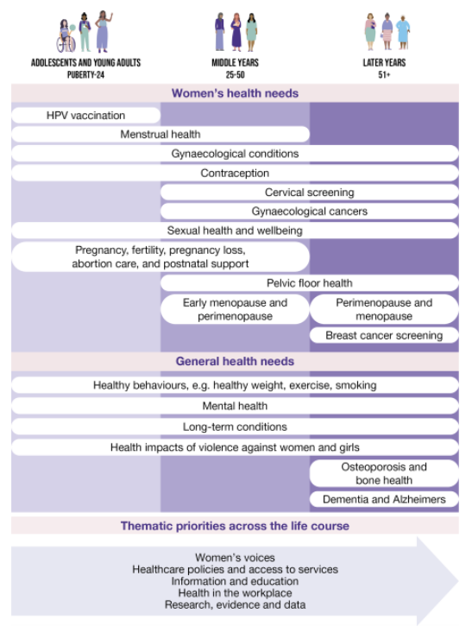

- Purpose
The aim of this group is to assure and support improvement of access to and experiences of care, improvement of health outcomes for women, and reduction of health inequalities, by overseeing the development of Women’s Health Hubs as set out in the women’s health hubs: core specification (2024). The intention to bring together healthcare professionals and existing services to provide integrated women’s health services in the community, centred on meeting women’s needs across the life course.
The purpose of this document is to outline the framework and governance that will be in place to ensure delivery of the Women’s Health Strategy for L&SC with the priority areas set out are as follows;
- Joined-up and co-ordinated care between health care systems, local authorities, voluntary and community sector, and patients.

- Improve outcomes in population health and healthcare.

- Improve patient experience, with care being delivered in one appointment where possible.

- Improve access to health information.

- Tackle inequalities in outcomes, experience and access.

- Enhance productivity and value for money.

- Help the NHS support broader social and economical development.

- Responsibilities of the Women’s Health board
The board will have specific responsibility to:
- Develop and maintain shared clinical governance.

- Oversee and monitor progress in delivering the National Women’s health programme.

- Provide a mechanism for joint action and joint decision-making for those issues which are best tackled on a wider scale.

- Address unwarranted variation in service provision and clinical outcomes for Women’s Health across L&SC.

- Encourage innovative thinking, new approaches and improvement in support and care with across the system.

- Work closely with other Partnership programmes to promote the objectives of the programme and ensure a consistent focus on improving services for the benefit of the population of Women across L&SC.

- Maintain a risk matrix to support the active monitoring and focus on Women’s Health Delivery plan to ensure delivery and impact.

- Oversee a consistent approach for assurance and accountability.

- Adopt an approach to making joint decisions and resolving any disagreements which follows the principle of subsidiarity and is in line with the shared values and behaviours of the partnership.

- promote sharing and learning across LSC in relation to Women’s Health services, share best practice initiatives and encourage, adopt and spread.

- Determine, monitor progress and mobilise improvement initiatives against a number of Key Indicators as specified within the national Strategy. These may be implemented in collaboration with the relevant ICP.

- Receive reports and data in relation to workstream, risks and issues including appraisal of any variation to time, cost and quality of workstream and/or programme deliverables.

- Ensure that within this process, workforce considerations are taken into account.

- Accountability/QS
This board reports into:
- ICB Quality Committee
- ICB People Board (where workforce interfaces with this programme)
- ICB Prevention and Health Inequalities Steering Group
- NHS E Women’s Health programme
(insert diagram)

- Memberships
The membership includes:
- L&SC ICB Director Of Women, Children, Young People and Maternity (Chair)
- L&SC ICB Associate Director, Maternity, Newborn and Women’s Health (Deputy Chair)
- L&SC ICB Womens Health Clinical Lead
- L&SC ICB Women’s Health Delivery Manager
- L&SC ICB Head of Service for Planned Care
- L&SC ICB Senior Population Health Managers
- L&SC ICB Directors of Health and Care Integration
- L&SC ICB Integration Place Leads
- L&SC ICB Programme Manager for Mental Health Transformation
- L&SC ICB Performance Lead
- L&SC ICB Senior Delivery Assurance Manager
- Local Authority Sexual Health Commissioners
- L&SC Gynaecology Network Chair
- L&SC Primary Care Leads – GPs, Dentists and Pharmacists – need to identify
- Local Authority Public Health Representatives
- L&SC Maternity, Newborn and Women’s Health Transformation Programme Manager
- L&SC Maternity, Newborn and Women’s Health Public Health, Prevention and Early Intervention Strategic Clinical Manager

Deputies
Members of the Board should identify a deputy for the occasions when they are unavailable and supply the name of their nominated deputy to the Chair. The deputy must be able to fulfil the role and be fully empowered particularly with respect to decision making and risk management.

Quorum
For decision making purposes, the meeting will be considered to be quorate if these are present:
Chair or deputy chair
ICB WCYPM
ICB planned care commissioner
LA commissioner
1 representative from every Task & Finish group

Board members (or nominated deputies) must attend at least 60% of meetings per annum.

Senior Responsible Officer (SRO)
The SRO will chair this Board and be responsible for:
- Setting priorities for the board
- Providing strategic direction and decision making
- Establishing the programme’s governance arrangements and ensuring appropriate assurance is in place
- Ensuring the Board achieves its overall objectives and delivers anticipated benefits
- Monitoring the progress of the programme
- Monitoring the key strategic risks facing the programme
- Escalating issues as necessary and in a timely manner
- Maintaining the interface with key senior stakeholders, keeping them engaged and informed.

Meeting arrangements
- The Women’s Health Board will meet Bi-Monthly.
- These meetings will be via MS Teams and will last approximately 1.5 hours. On some occasions these will be held face to face. If the need arises in between the meetings for a key decision to be made, an additional call will be arranged in the interim.
- The Chair or any forum may at any time convene extraordinary meetings to consider business that requires urgent attention.
- Administrative functions will be provided via the ICB WCYPM team.
- All papers agreed by the Chair should be received by the Administrator a minimum of 7 working days in advance of the meeting.
- Agenda and papers to be agreed with the Chair a minimum of 4 working days before the meeting.
- Agenda and papers will be sent out a minimum of 7 working days before the meeting.
- Minutes and the action log will be sent out 5 working days after the meeting.

Dispute resolution:
Partners will attempt to resolve in good faith any dispute between them in respect of Women’s Health Board (or other Partnership-related) decisions, in line with the Principles, Values and Behaviours agreed by the Board.
The Board will apply a dispute resolution process to resolve any issues which cannot otherwise be agreed through these arrangements.
As decisions made by the Women’s Health Board do not impact on the statutory responsibilities of individual organisations, partners will be expected to apply shared Values and Behaviours and come to a mutual agreement through the dispute resolution process.

- Declaration of Interest
All new declarations of interest must be notified to the Chair within 28 days of a member taking office of any interests requiring registrations, or within 28 days of a change to a member’s registered interests.
Declaration of Interest processes will align to ICB arrangements once they have been formally accepted.

- Appendices
12.1 References
Womens health Strategy for England (2022), Department of health & Social care,
Women's Health Strategy for England - GOV.UK (www.gov.uk)

Women’s health hubs: core specification (2024), Department of health & Social care,
Women's health hubs: core specification - GOV.UK (www.gov.uk)

Women’s health hubs: Cost benefit analysis (2024) Department of health & Social care,
Women's health hubs: cost benefit analysis - GOV.UK (www.gov.uk)

Better for Women (2019), Royal College of Obstetricians and gynaecologists
Better for women: Full report (rcog.org.uk)

https://www.gov.uk/government/publications/womens-health-hubs-information-and-guidance/womens-health-hubs-core-specification

