**Barriers to cancer screening – listening to views from black and minority ethnic (BME) women in Preston**

Analysis report

26 June 2024

NHS Lancashire and South Cumbria ICB communications and engagement team

[lscicb.communications@nhs.net](mailto:lscicb.communications@nhs.net)

Contents

Acknowledgements 1

Introduction 2

Executive summary 2

What have we been talking to people about and why? 3

Who have we heard from? 4

How did we speak to people? 4

What did we hear? 5

Insights we have gained from this process 6

Next steps 7

# Acknowledgements

The ICB would like to thank everybody who took the time to participate in this engagement session, particularly the ladies at Sahara in Preston.

# Introduction

People and communities are important to us because they help us improve all aspects of health care, including patient safety, patient experience and health outcomes – giving people the power to live healthier lives.

Public involvement and listening to all of our communities is an essential part of making sure effective and efficient health and care services are delivered. By reaching, listening to, involving and empowering our people and communities, we can make sure they are at the heart of decision making.

Sahara in Preston is a voluntary organisation for women, working predominantly for the benefit of black and minority ethnic (BME) women. It was established to ensure that the social, economic and welfare needs of the women from BME communities in Preston were fully recognised and met by the public and voluntary sectors and that they were enabled and encouraged to participate in the wider society.

Sahara reached out originally to Macmillan Cancer Support about wanting the voices of the women they are supporting to be heard to understand why they don't attend screening programmes for breast, bowel and cervical cancers.

# Executive summary

Over 200 South Asian ladies were invited to a listening event at the end of June 2024 at Sahara’s community centre in Preston. Sixty-three ladies turned up ranging in age.

The session, organised by Macmillan Cancer Support, was facilitated by Zafar Coupland, Sahara’s manager, with clinical conversations led by Dr Ewa Craven, the ICB’s women’s health clinical lead, and colleagues from the breast and bowel cancer screening programmes. Discussions along with practical demonstrations around each of the three cancers and why screening is important and what it involves were held in both English and Urdu as a number of the ladies present did not speak English..

Time was given for questions and answers after each of the speakers. Discussions were open and honest and at some points uncomfortable for the ladies particularly those of a sexual nature concerning cervical cancer.

**Key findings:**

There were a number of key themes which arose from across all of the discussions:

* Language barriers
* Cultural barriers
* Embarrassment
* Fear – will it hurt?
* Lack of knowledge – don’t what to expect; don’t understand why it is important
* Don’t take cancer seriously

Insights from the group provided some explanations for why screening rates are lower in South Asian women including poor knowledge about cancer and signs and symptoms, how certain cancers can affect them individually and why cancer screening programmes are important. Cultural barriers to talking about cancer were raised along with poor communication between health professionals and patients including language barriers, and fear and embarrassment of what the screening process involves. In discussions around cervical screening, comments explained if you talk about sex then you are seen to advocate it. In a Muslim household, conversations around the topic of sex do not take place between unmarried daughters with their mothers, sisters or aunties. Whilst the community needs to accept there are some young people (both female and male) who are becoming sexually active even if unmarried, there are still a lot of young people who have a strong faith and wait until they are married.

The arrangements for capturing insights in the room from all participants were not ideal and better planning around how these types of conversations can be facilitated to be more inclusive of views from others in the room will be considered and actioned by the ICB communications and engagement team.

# Subtitles with solid fillWhat have we been talking to people about and why?

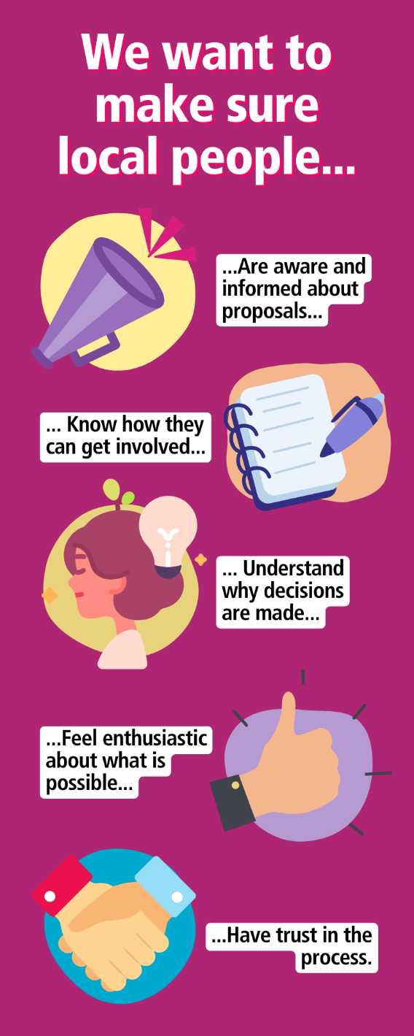

There is a huge demand for information in relation to women’s health issues and the risk that if it’s not provided by accredited services is that misinformation, misconceptions and fear can happen as a result, which will have a negative impact on women’s health.

There are also aspects of women’s health still considered a taboo which can leave women feeling alone and not understood.

A number of studies indicate that South Asian women generally have lower screening rates for cancer than white British women. Evidence suggests they have poorer knowledge of the signs and symptoms of cancer and cancer prevention and experience more barriers to screening.

This engagement project aimed to seek the views of those women connected with Sahara in Preston to understand what the barriers are to attending the national screening programmes for cervical, breast and bowel cancer and what can be done by health services to improve uptake.

# Group success with solid fillWho have we heard from?

We heard from 63 women, 61 were of a South Asian heritage and two of a North African heritage, with an approximate age range of mid/late twenties to those in their seventies.

# Megaphone1 with solid fillHow did we speak to people?

Following the introduction to the event, Helen Miller, partnership manager at Macmillan Cancer Support, provided a brief overview of Macmillan and how they work in the community. This was followed by Dr Ewa Craven who talked about cervical cancer, Janet Ellison from the Lancashire Breast Screening Team talked about breast cancer, and finally Shahida Hanif, health promotion specialist with the Lancashire Bowel Cancer Screening Programme talked about bowel cancer.

As there were ladies present who didn’t speak or understand English, a member of staff from Sahara translated conversations into Urdu.

Practical demonstrations were given on the processes used in both cervical and bowel screening. The ladies were shown the plastic speculum used to take the sample of cells from the cervix as well as how to take a poo sample for bowel cancer testing.

Three members of the ICB’s communications and engagement team were present to listen to discussions and take notes, capturing the insights which have been collated into this report.

Following each topic, a question-and-answer session was held. These have been grouped into themes which are outlined in the next section.

# Ear with solid fillWhat did we hear?

Overall, we heard there is a lack of understanding and education about cancer and signs and symptoms. There are some key barriers to attending for screening, mainly relating to language, culture, fear of pain and the unknown and what to expect which also comes from the lack of information supplied, whether in English or other languages.

Language remains a main barrier, information is primarily supplied in English with an expectation that a family member can translate for them. However, this is not always appropriate given the sensitivity, or complexity, of some of the issues and information. Equally, people do not like to use Language Line, which again is not always appropriate to discuss health issues via a stranger.

Another main barrier remains cultural. Some topics are still not discussed within the home especially if relating to sex or the female body. The women explained they come from a faith where their bodies are always covered up and apart from their spouse no one has even had sight of their arms let alone other private parts. For this reason, they find going forward for intimate examinations a huge challenge.

**Language barriers:**

The group shared feedback that Language Line is not always appropriate, stating that the context gets lost in translation, it becomes too complicated, and misunderstandings arise. It was felt that women don’t want to be talking about sensitive and private topics, such as their vagina, with a stranger on the other end of a telephone.

The group shared that there can be little or no support from home or the health system with language, a professional who has the appropriate language skill who can explain pathways and treatments is needed.

Letters and other information are supplied in English, although not all speakers of other languages can read their written language. While family can help to some extent, there is difficulty when children have to get involved if they are the only option for translation. It was felt by the group that this isn’t appropriate, and a child can misunderstand the information and interpret it incorrectly.

**Cultural barriers:**

The feedback from the group included that even though some young people are sexually active, conversations about sex do not take place between unmarried females. There are still many young girls who hold a strong faith in their religion though and will wait until they are married.

It was stated that women have been brought up not to explore their bodies or show certain parts, so intimate examinations are a real challenge. For instance, a woman cannot go to her son and tell them they have a breast lump. Those conversations do not happen.

It was shared that husbands do not understand the reasoning for a mastectomy, especially if reconstruction is not carried out, or accept it. In these instances, some mothers-in-law tell their sons to re-marry and take a new wife. The reality is that women are being told not to have lifesaving surgery in order to save their marriage.

**Embarrassment, fear or lack of knowledge:**

These have been grouped together as it can be assumed that in some cases, embarrassment and fear can be fostered due to lack of knowledge.

Some of the ladies thought screening might be painful, or it might be a male carrying out the procedure. They are embarrassed about people looking at them, it can scare them and put them off. In addition, fear if they had cancer and fear about going through treatment. Reassurance was given that whilst some of the procedures may be a little uncomfortable, there should be no pain. Women also have the right to request a female practitioner, and that in the instance of breast screening this is always a female mammographer. They also have the right to request a chaperone, whether a staff member from the clinic or a friend/family member.

More education was felt to be needed around the different signs and symptoms of cancer and the reasons why the screening programmes are so important.

When an appointment is sent, all of the information included should include the benefits and limitations of the test, as well as the practicalities. Information should be provided in the appropriate language or format.

Members of the group said it would be good if information about screening is explained when having your first baby.

Members of the group felt women don’t understand the different stages of cancer, or the treatment. the group felt this is where a professional who can talk to the patient about pathways and treatment in their own language can be vital.

# Exclamation mark with solid fillInsights we have gained from this process

This was a large engagement event with members of the public, of whom many do not speak or understand English. Whilst not led by the ICB, it was clear that there were too many participants to effectively facilitate an open room discussion.

The initial plan was to hold discussions per table with an interpreter and professional at each of the table and listen to the conversations of the ladies prompted by a pre-developed questionnaire.

Though participation in the room, which was quite small and cramped for the amount of people in it, was positive unfortunately conversations and key points were most likely missed due to the number of separate conversations taking place at the same time.

Due to the audience being all-female and South Asian (majority) it was correct that health colleagues present were also all-female. The audience needs to be considered when planning any future events. In addition, room layout and facilitation of conversations needs to be considered more carefully.

# Next steps

This report will be shared with the ICB’s women’s health team and the ICB’s cancer team to consider the points raised and use the insight to influence future service provision.