Virtual Ward

Patient engagement report

**July 2023**

# Introduction

Virtual wards were established in the second half of 2022. to allow patients to get the care they need at home safely and conveniently, rather than being in hospital. They enable more people to receive the acute care, remote monitoring and treatment they need in their own home.

The first virtual wards launched in a staggered approach in the August and have been growing ever since. Since their establishment, a programme of patient engagement has been encouraged to ensure quality of service and to enable continuous review and improvements to services.

As at June 2023 the below infographic shows the state of virtual wards.

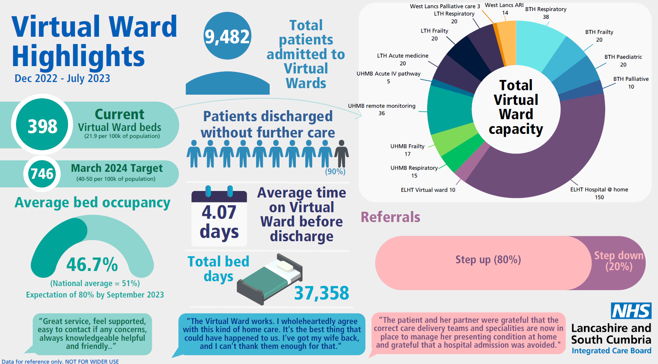

# Engagement methodology

Staff contacting patients have had a number of options to gather feedback. This has been through anecdotal evidence, friends and family test, identifying case studies patients and through a survey. Each provider had done this differently but over time it has become more streamlined. A standardised survey has been created in the past year which patients are asked to complete upon discharge from the service.



Below is a breakdown of the way patients have been kept informed and feedback gathered in each area.

Fylde coast

* Patient information leaflets issued
* Friends and family test
* Patient survey
* Co-production planned going forward

Morecambe Bay

* Patient information leaflet
* Friends and family test
* Compliments and complaints all recorded
* Patient stories / case studies gathered

Central Lancashire

* Patient leaflets
* Friends and family
* Compliments and complaint procedure
* Attendance at patient experience forum

Pennine

* Patient leaflet
* Patient leaflets
* Friends and family
* Compliments and complaint procedure
* Case studies gathered

# Case studies

The following are samples of case studies or links to documents with more.

## Respiratory VW patient feedback (LTHTR)

"Following an episode around my bronchiectasis I attended Preston Hospital A&E. After being seen by a doctor I was then referred to the Respiratory Team and transferred to the Medical Assessment Unit where I was monitored and assessed by a member of the team. During this time I was put on a nebulizer, had my medication reviewed and had an in-depth discussion regarding my symptoms and their management. Following on from this, a decision was taken, and agreed to by myself, to continue under observation at my home via a 'virtual ward'. This involved regular contact with the team at an agreed time, every few days. During our phone conversations we were able to discuss my condition, how things were progressing and to receive advice on my management of the condition.​

The benefits of being at home rather than being admitted to hospital were, to my mind many fold. Firstly, I did not need to take up a bed when, generally speaking, my condition did not require it, given that it was observation rather than treatment that was needed. Having an agreed time when contact took place gave me the freedom to continue with my day-to-day life knowing that should anything medical arise I had a direct link to the team. Having a personal conversation gave me the opportunity to discuss my concerns and seek advice in an environment that was calm and on my terms, it made me feel valued and listened to without the distractions that might have been present on a hospital ward.​ ​Personally, may I add my thanks to the team for their professionalism and expertise during this time.​"

<https://vimeo.com/776241896/ea361a4ac1>

## Windermere couple praises new UHMBT ‘Virtual Ward’ care

A new ‘Virtual Ward’ service provided by University Hospitals of Morecambe Bay NHS Foundation Trust has been praised by a Windermere couple.

Roger and Patricia Bottomley have shared their experience after Patricia broke four toes in a fall at home in July.

Patricia, 86, was taken by ambulance to Royal Lancaster Infirmary where investigations revealed that she had had a number of mini strokes and was showing early signs of dementia.

After assessment at the hospital’s Acute Frailty Unit, she was referred to the South Lakes Rapid Response Team, and sent home as a patient on the Team’s ‘Virtual Ward’.

Nurses working with the Virtual Ward meet with a consultant geriatrician daily, offering an enhanced level of care for patients who are able to be cared for safely at home.

Roger, 81, said: “A nurse from the Virtual Ward came to visit Patricia every day.

“The nurses were excellent – they were very pleasant and caring and made us feel very comfortable. They have been absolutely superb.

“When Patricia has been in hospital overnight in the past it’s been very, very stressful, but when she’s at home she’s relaxed and comfortable.

“The Virtual Ward works. I wholeheartedly agree with this kind of home care. It’s the best thing that could have happened to us. I've got my wife back, and I can’t thank them enough for that.”

UHMBT currently has capacity to care for up to 27 patients through its virtual wards, and aims to expand to 150 by September 2023.

Bridget Lees, Executive Chief Nurse, UHMBT, said: “Our Virtual Wards mean we can provide a higher level of care for patients while also offering them the comfort and stability of remaining in their own home.

“The Virtual Ward system also helps to prioritise hospital beds for people who need them.

“I am pleased to hear that Mr and Mrs Bottomley had a good experience with our Virtual Ward, and thank our clinical teams for making a success of this innovative way of working.”

## FCMS (Fylde Coast)

A 68 year old lady who was admitted onto the respiratory virtual ward with exacerbation of COPD not needing nebuliser therapy so admitted on the 4a pathway for monitoring.  The family supported her inputting her readings and found the service really beneficial as felt Mum was being looked after.

After 48 hours of monitoring the team noticed her pulse was becoming erratic and flitting all over and high – the patient started feeling more SOB and saying needing her Salbutamol more with little effect.  This was not right so we spoke to medical cover as the team were concerned she could potentially be a new onset of Atrial Fibrillation – the medical team accepted her.

48 hours later the patient was discharged back to the 4a virtual ward and had been diagnosed with AF – she had been started on bisoprolol and her pulse was settling.  On being discharged the patient and family were extremely grateful as without this service this may not have been picked up. The patient had recovered well from her COPD exacerbation as well and the appropriate follow up was arranged.

## Patient stories - 2h UCR (LSCFT)

 

# Survey results

The survey has so far been completed 62 times (38 times via the online/paper survey and 24 times through a separate Docobo system using the same questions) . Patients are encouraged to complete the survey but are under no obligation to do so.

The majority of respondents are from the East Lancashire area (BB postcodes) or the Fylde coast (FY postcodes).

Respondents match the expected demographics of the services that being mostly between the ages of 46 to over 85 with the majority falling in to the 76-85 bracket.

All respondents reported as being white or preferring not to say.

There was an exact 50/50 split between male and female patients.

23 patients reported having a disability of some kind with the majority of these being a long-term health condition or physical impairment.

The response to questions is shown below:

Following this question patients were asked if they found the Docobo system easy to use and what comments they had about it? Comments included:

* Easier than I thought it would be
* Thermometer was broke
* Partner found it very easy.
* No problems, very easy.
* Good Idea. Few problems with readings at times usually in the mornings.
* depending on days sometimes hands didn't work efficiently but used approx 50%. telephoned when no readings received, reassuring to me.

When asked what the service did well comments included:

* I felt it was a good idea. If you have confidence in using the equipment, it is a great way to reduce the amount of people coming through your home whilst feeling secure that a health care professional was able to monitor remotely. It gave me my privacy.
* The device let you know if details required. I liked that all my details were correct. I liked that I was checked on
* Everything was good.
* The support and quick response.
* Felt supported and when needed was there.
* Everything! I was very anxious to go to hospital, the option of this service has put me at ease. I was provided with great explanations; the staff were extremely prompt when there were alerts and someone was on the phone to me very quickly which was reassuring. I had support and was reassured that there would be someone available during the night.
* Smashing service 5 stars. I would give 10 if I could.
* Felt the whole monitoring service worked well. Felt supported by it.

Themes of the comments were around the use of technology, how reassuring staff were and how patients felt supported even though not in hospital.

Patients were also asked what could be done better. The responses again were mostly very positive with the majority saying that they couldn’t think of anything that could be improved. The only constructive feedback was that the timings for sending readings were not always convenient to them and that the service was difficult for people with disabilities with one citing difficulty using the monitors due to their disability and one suggesting the information should be easier to read for those visually impaired.

One comment stood out in the ‘any other comments’ section where 18 people left very positive comments, it read:

Cannot say enough about the service. I was having a lot of delays in getting appropriate support from my GP, the ability to monitor at home allowed me to stay home from hospital reduce my anxiety and be around for my grandchild who I have custody of. The autonomy to look after myself was a good part of the service whilst also having easy access to someone on the other side of the phone quickly who can offer support and reassurance when needed. I a a very health conscious person and knowing my baselines and being able to care for myself was a good experience for me.

# Conclusion

The service is meeting or exceeding patient expectations with the overwhelming feeling being that it is an excellent service that is easy to use and makes the patient feel reassured.

The positive experience of the service is created by the level of information provided, the friendly and supportive staff interactions with patients and the convenience and ease of use of the technology.

However, there is still only a small number of respondents to the survey compared to the number of patients that has been through the service (less than 1 per cent). Although we must remember these are potentially still unwell albeit not in need of monitoring and therefore would not be in a frame of mind to complete a survey. This should be allocated for with patients being sent the survey sometime after discharge.

We should also note that as providers create different services such as the paediatric virtual wards the questioning may need to be amended to identify which particular ward they have been a part of so that each service can be analysed and learning shared.